A Valentine Pop-up Card for Someone You Love

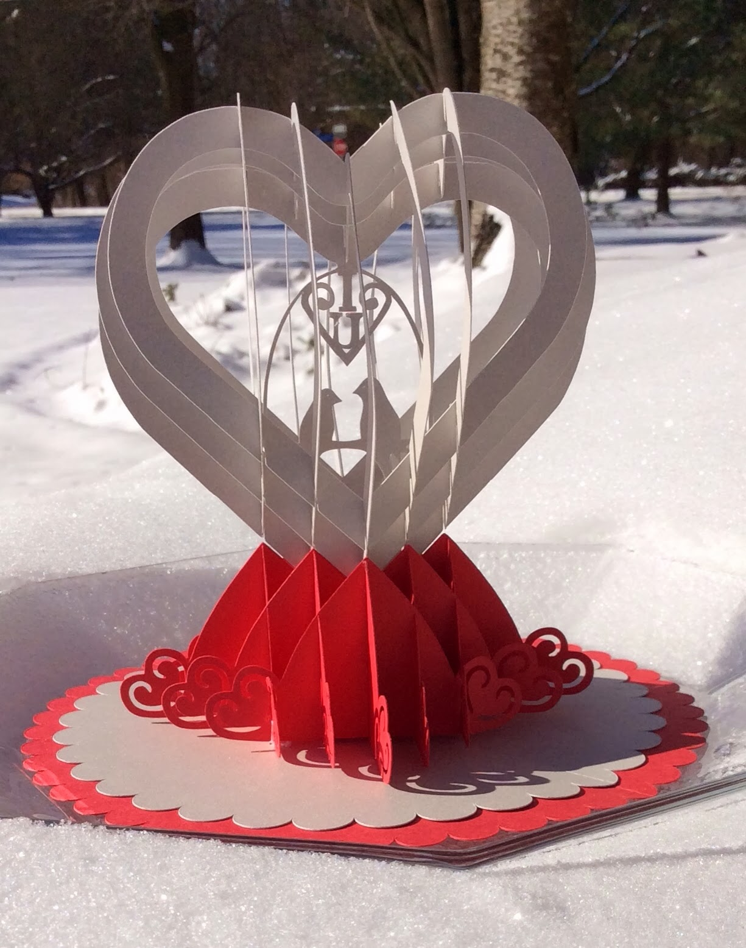

Valetine Pop-up. This will fold flat for mailing.

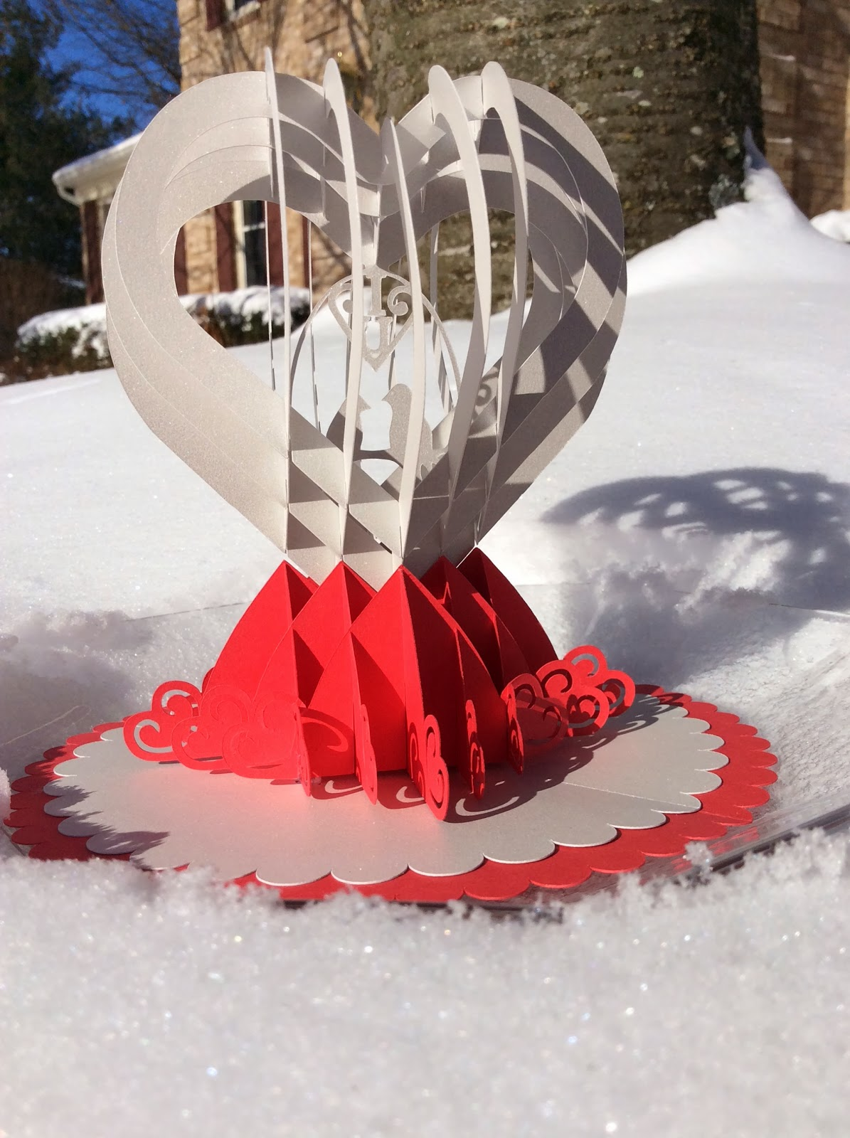

My Valentine pop-up looks pretty in the snow. I used iridescent white paper and it blends in well with the 5 inches of snow and 7 degree temperatures...second day of no school...more time for crafts!

This is my first attempt at making a real pop-up card. I didn't use a program...just brute force. I would love to have the new Pop-up computer program from Make the Cut (it is on my wish list...maybe for my birthday) but I don't think I could have made this design with it because there are there are too many pieces that slide together.  
  
 I love the birds sitting on the branch and the heart symbol above with the I and U. It is supposed to represent "I love you" or "I heart you". My husband did not see it...he thought it was just scroll work until I pointed it out. This design is similar to my previous design but I removed one of the slices. When the heart lays flat, the heart symbol is prominent in the center.  
  
 I recommend using a good quality cardstock as the slits are very tight. I find that some cardstock does not work as well as others. It is strange...sometimes certain colors in the same stack of cardstock are better than others. I buy my cardstock at Target and Michaels in case you were wondering.  
  
Follow the directions to make the sliceform heart from a previous post.  
<http://papercraftetc.blogspot.com/2014/01/a-paper-sliceform-heart-table-decoration.html>Make the sliceform base using these directions from a previous post.  
<http://papercraftetc.blogspot.com/2013/12/paper-snow-globe-sliceform-for.html>

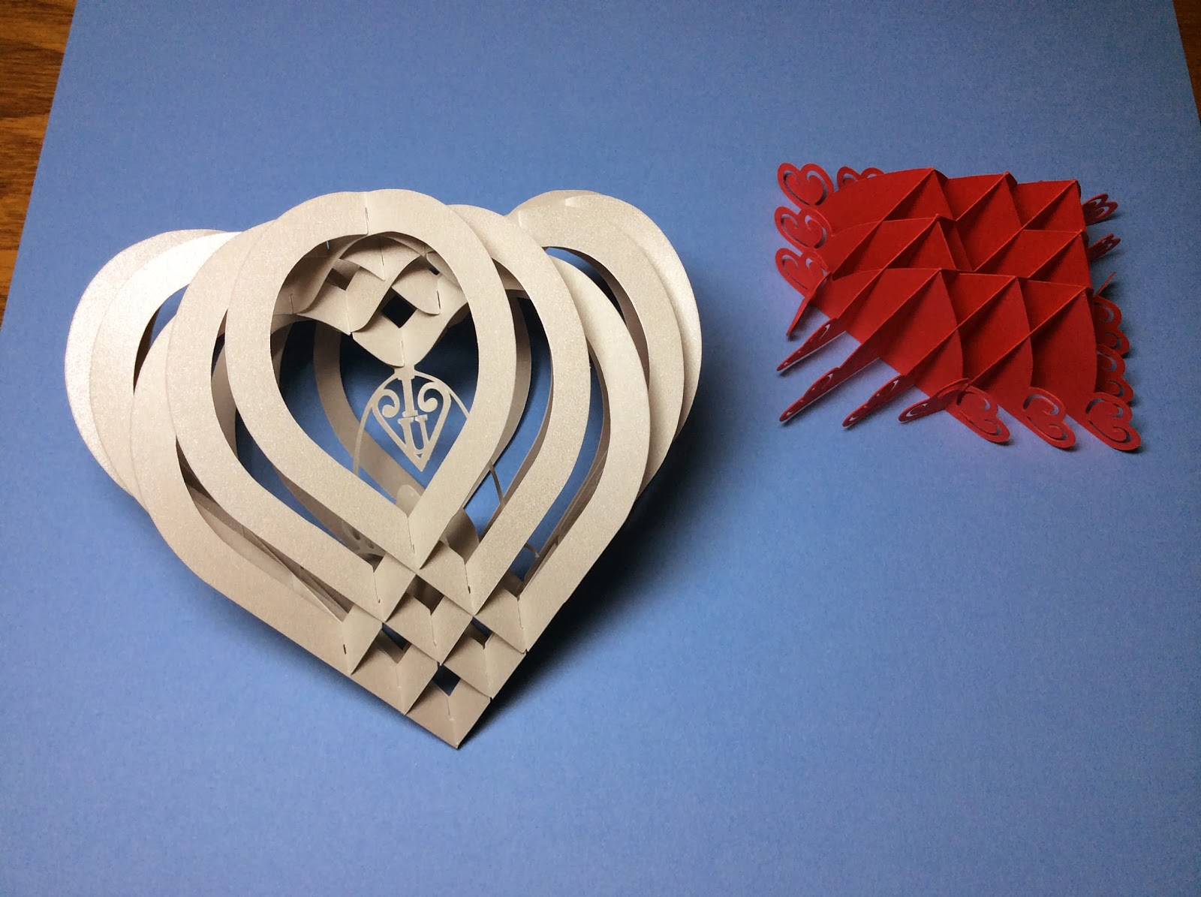

Sliceform Heart and Base

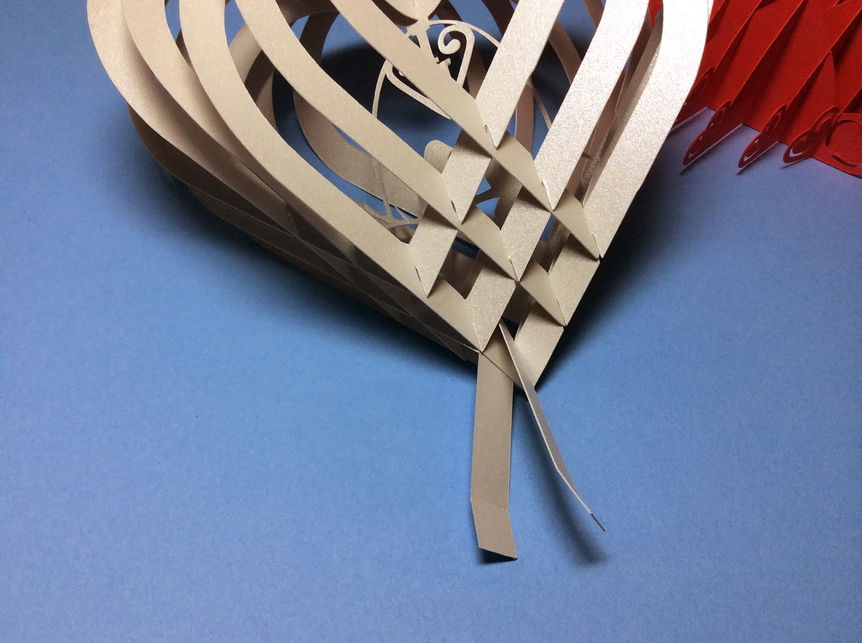

Loop the tab over the point.

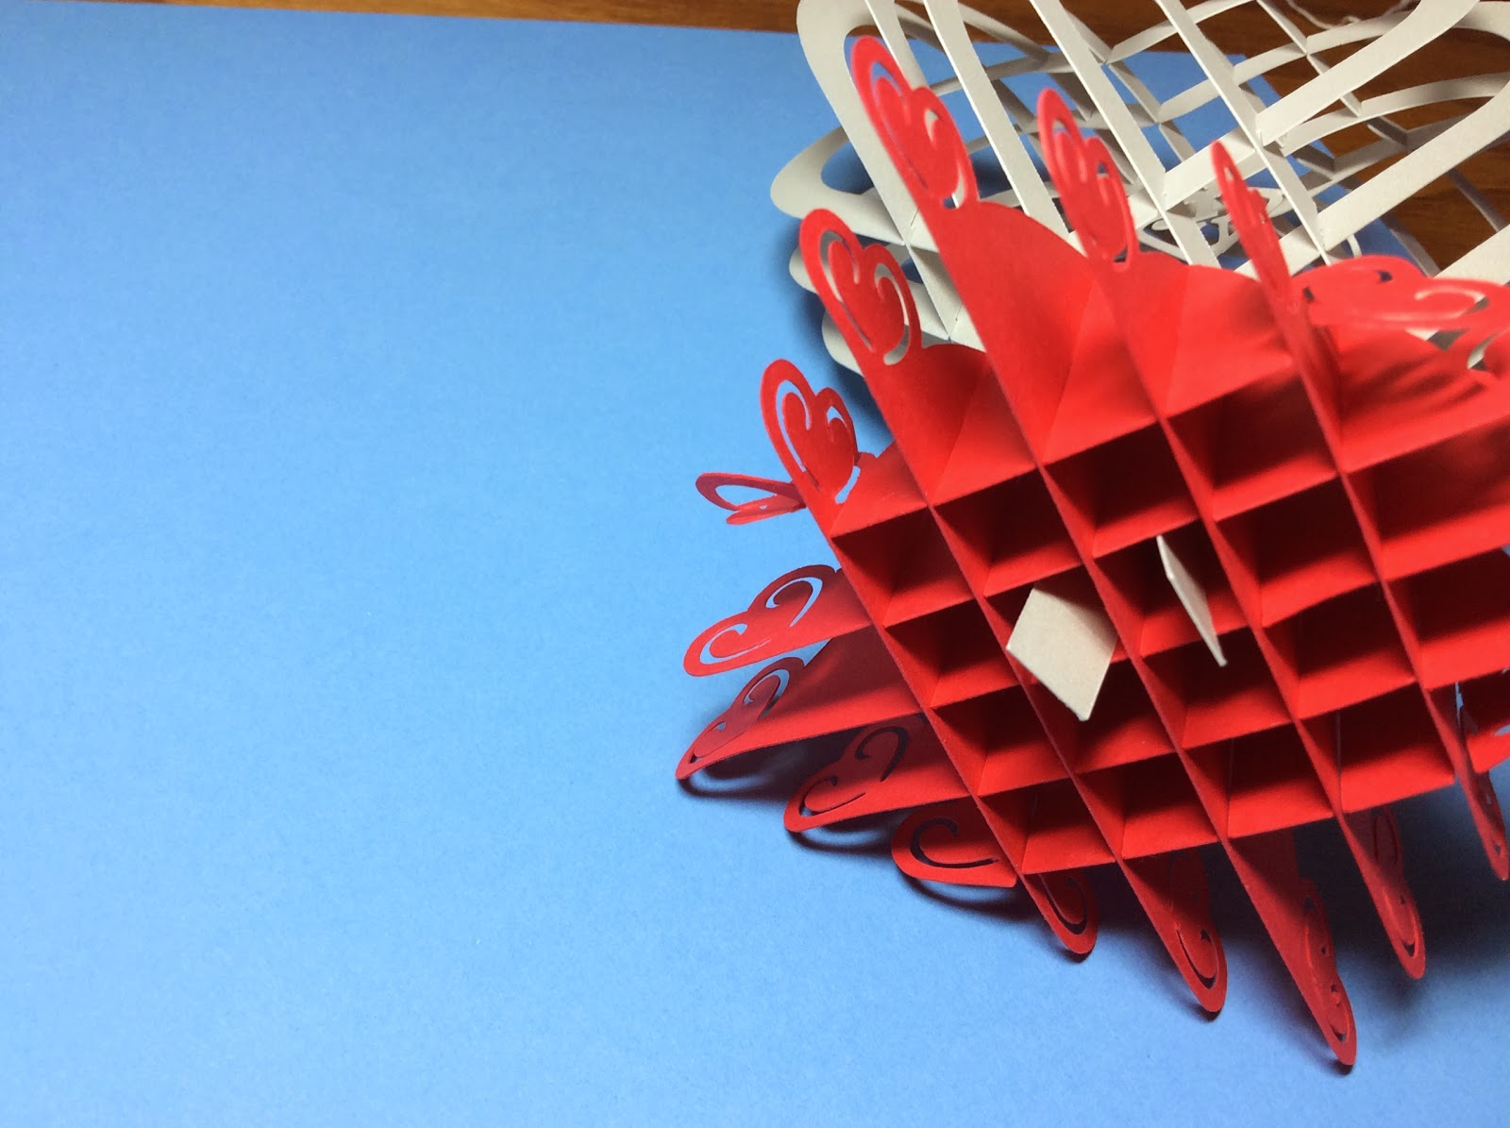

Loop the tab through the base as shown. The tabs are split between the two sides.

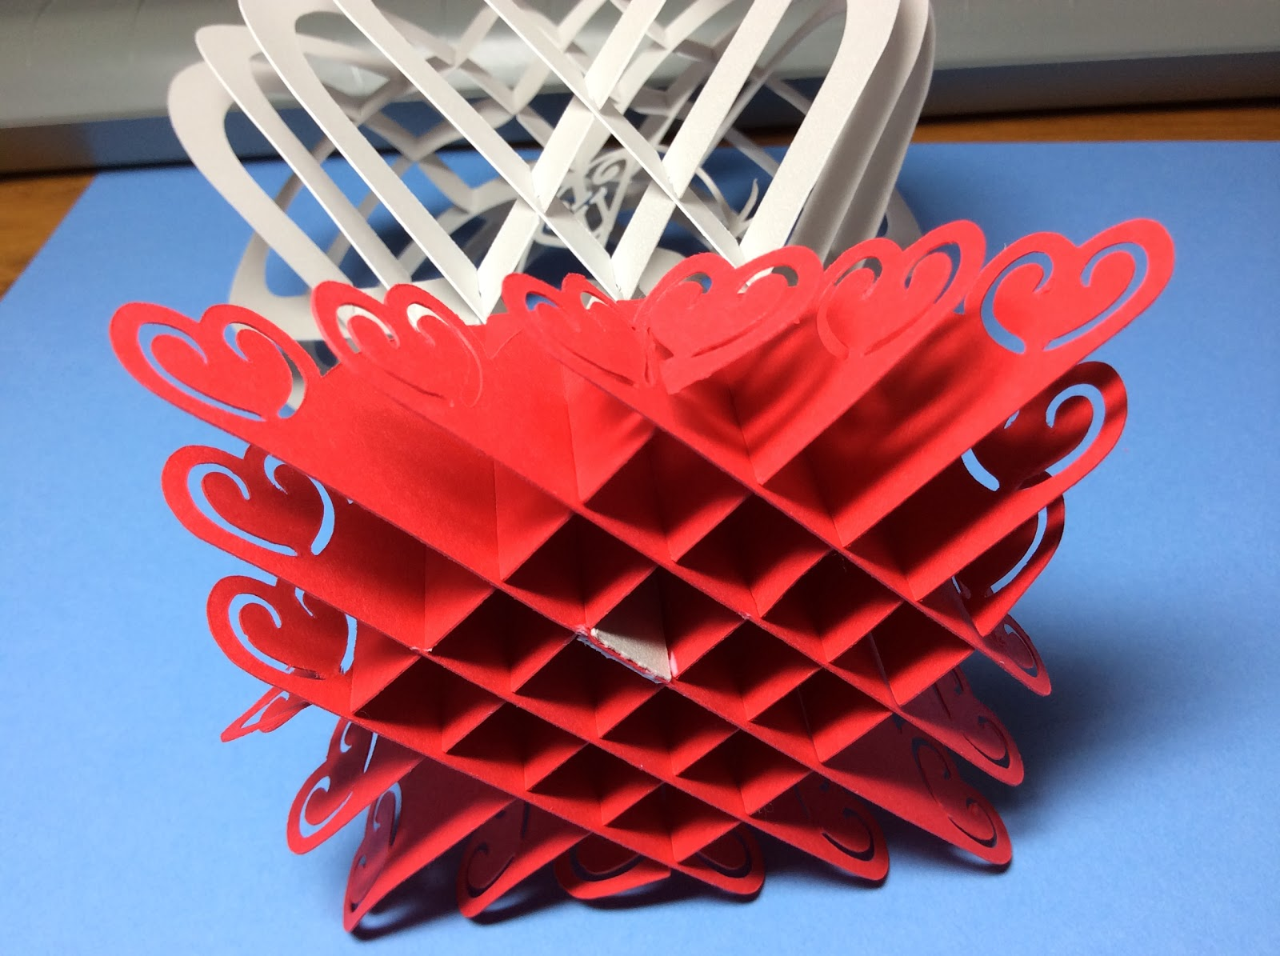

Glue the tabs to the side and tear away the excess paper.

The Valentine Pop-Up looks nice even without the scalloped base. You can stop here if you do not want to sew the design to another base.

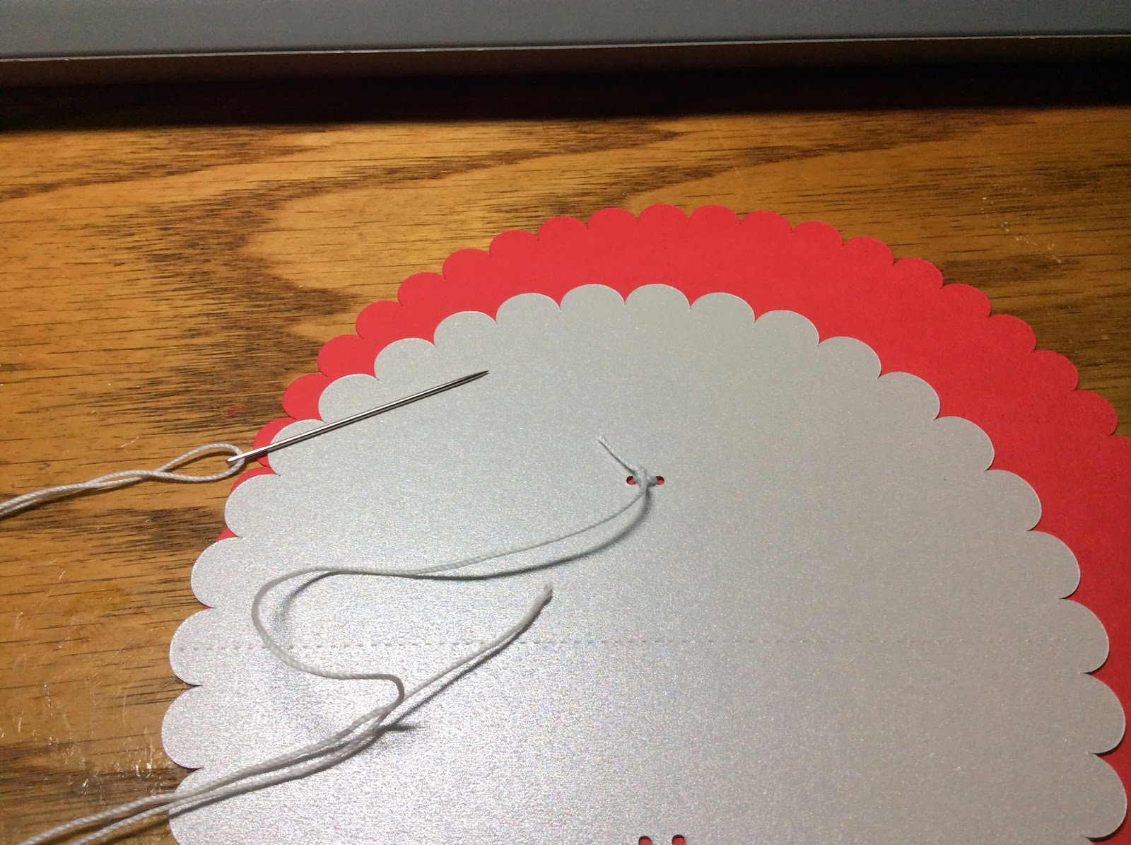

Knot the thread onto the scalloped base.

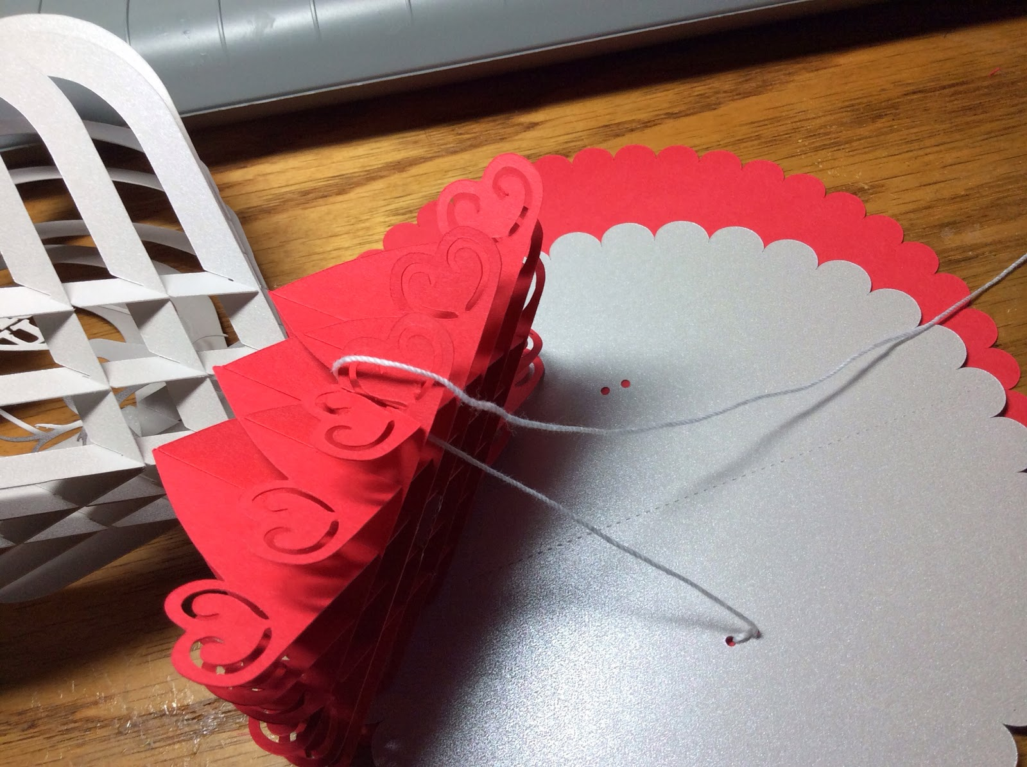

Loop the thread through the base at the lowest point as shown in the picture.

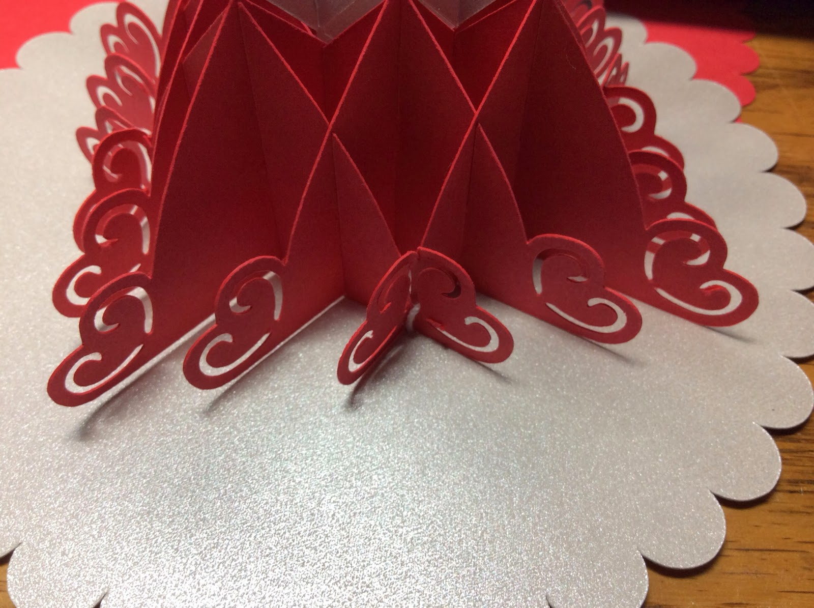

Thread it through the base. It is now attached at one point. Repeat for the other side.

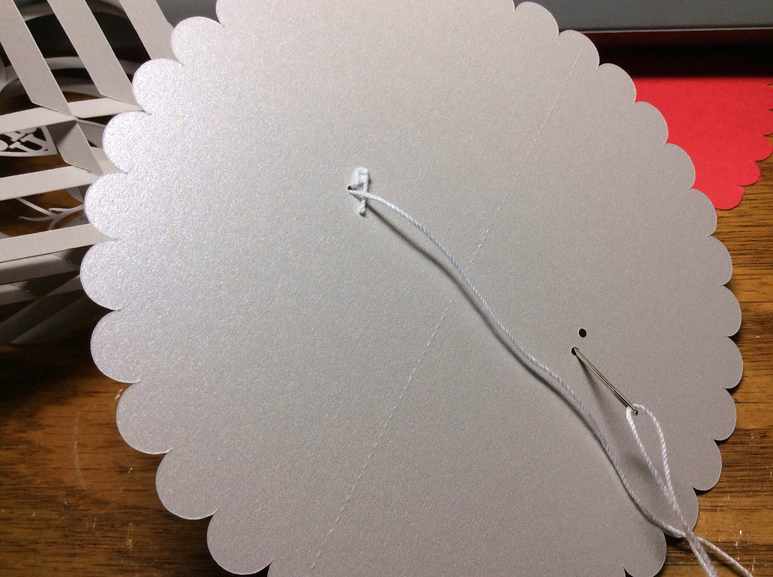

Thread it to the other side.

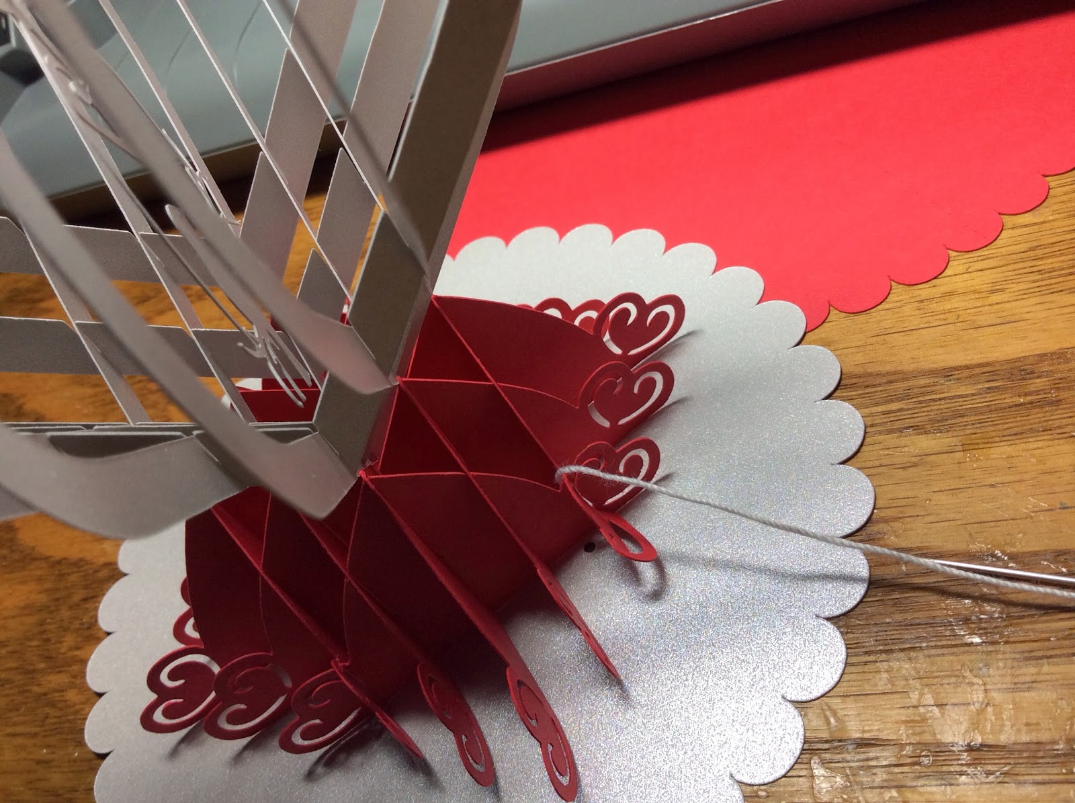

Loop it over.

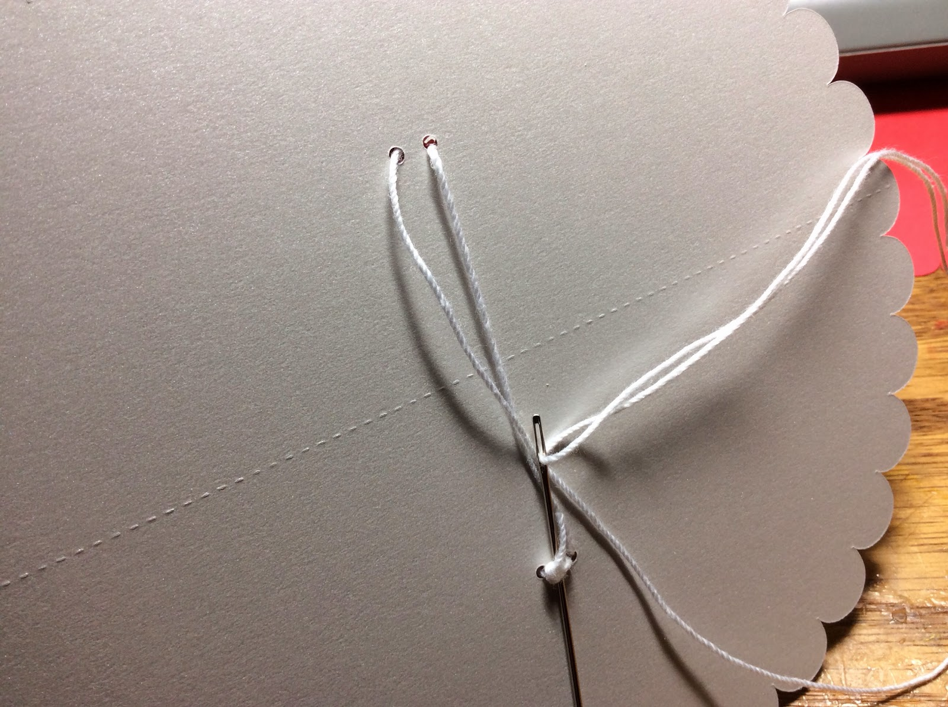

And knot the thread on the back side of the base.

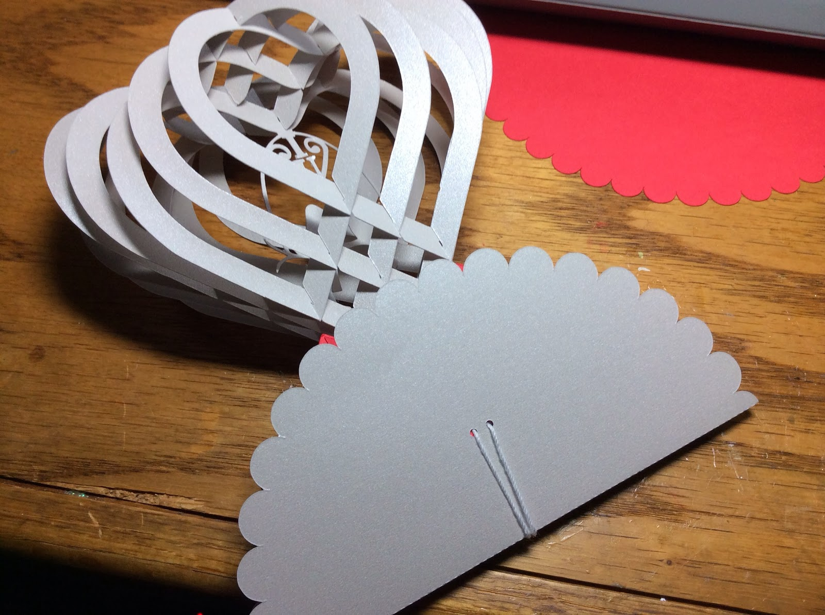

Here is what it looks like lying flat.

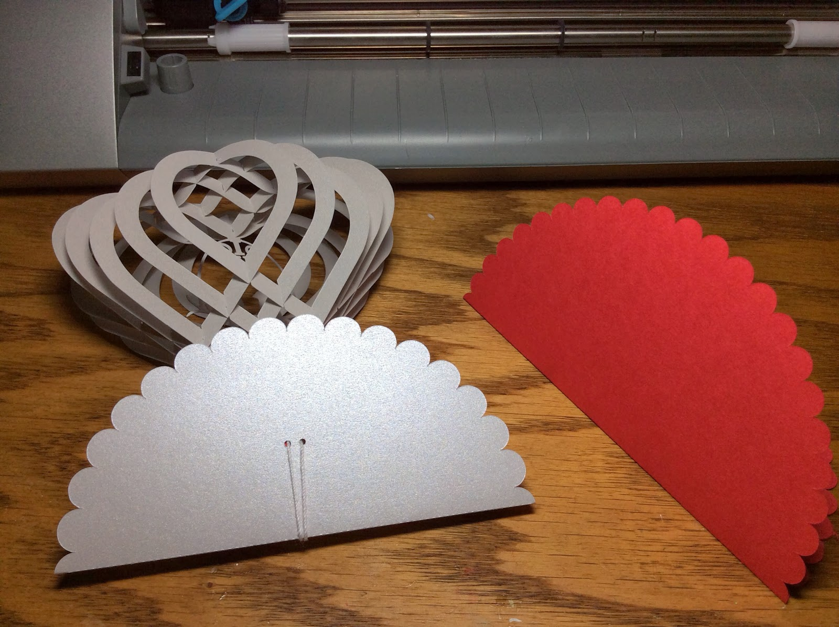

Fold the second base (red) in half.

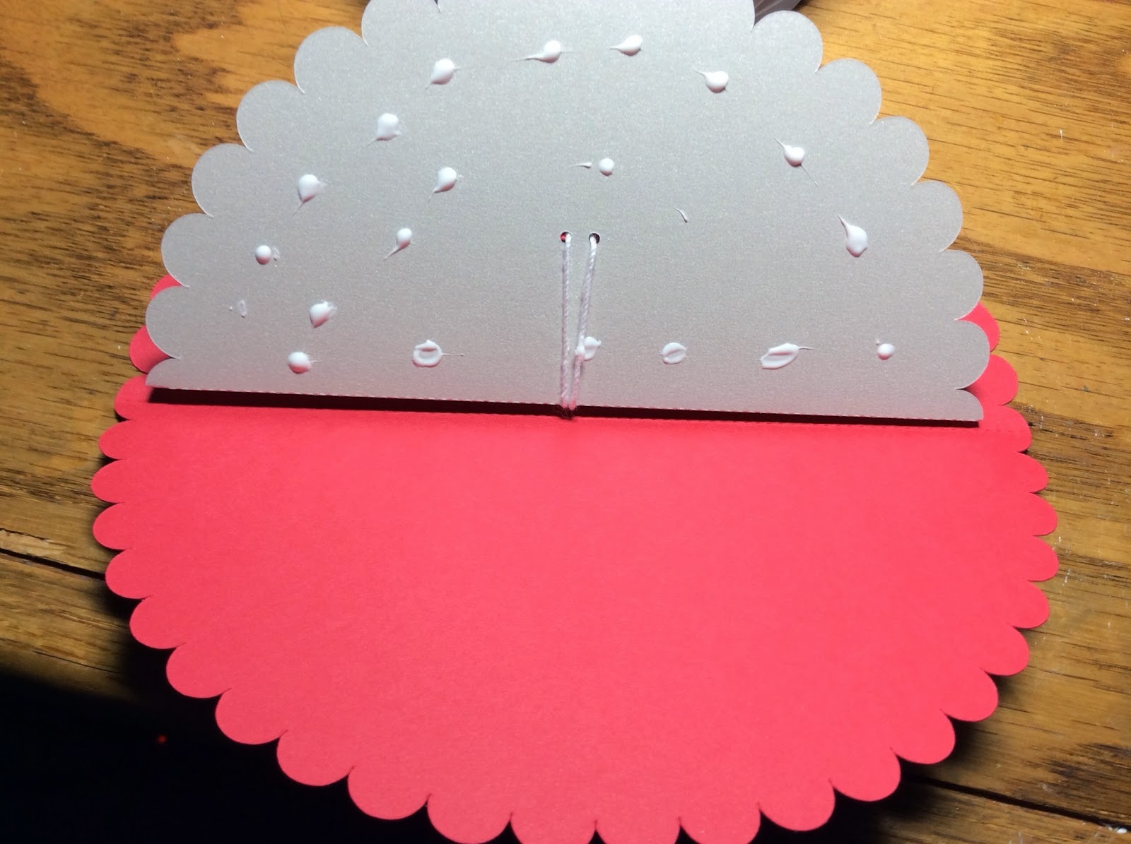

Put glue on the side that was sewn and combine both halves at the crease so that it will fold properly.

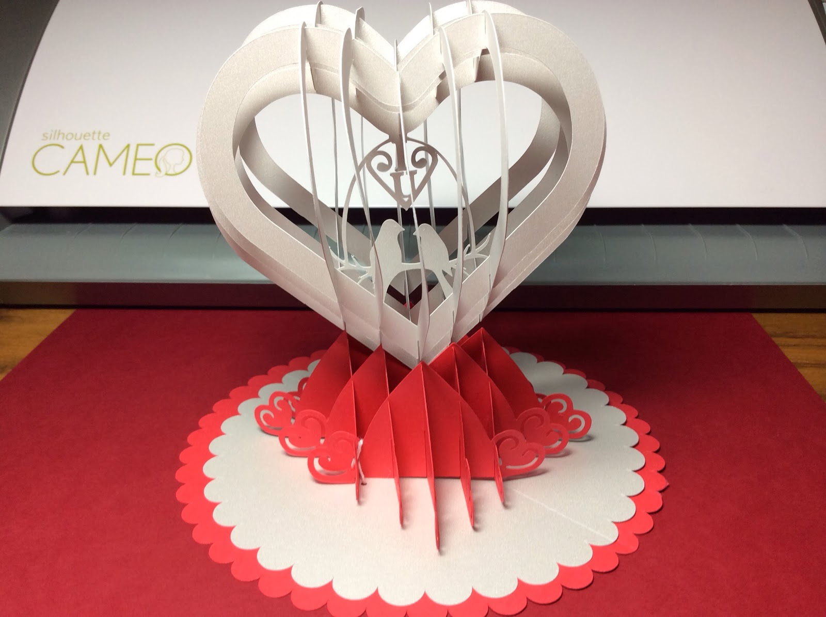

Completed Valentine Pop-Up

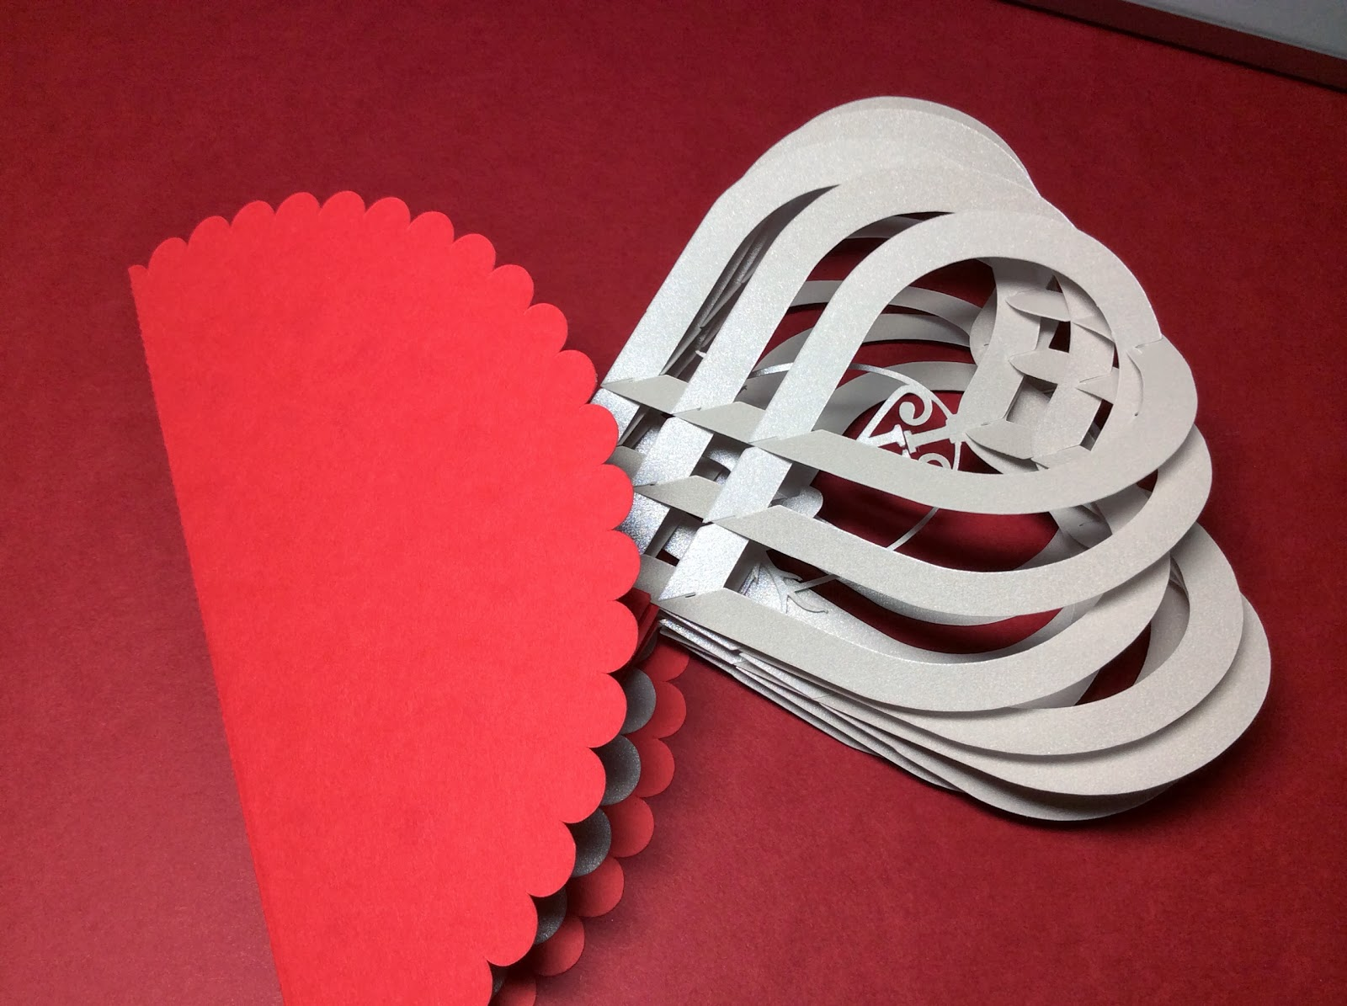

Here is what the pop-up looks like when folded flat...very pretty!